

AI-BASED LOCALIZATION AND
CLASSIFICATION
OF SKIN DISEASE WITH ERYTHEMA

NALAIYA THIRAN PROJECT BASED LEARNING

on

PROFESSIONAL READINESS FOR INNOVATION, EMPLOYABILITY AND ENTREPRENEURSHIP

A PROJECT REPORT

PAVITHRAA M R | 19104126
PRAGADESHWAR V | 19104128
PRASAD K | 19104130
GANESH S | 19104801

BACHELOR OF TECHNOLOGY
IN
COMPUTER SCIENCE AND ENGINEERING
HINDUSTHAN COLLEGE OF ENGINEERING AND TECHOLOGY
Approved by AICTE, New Delhi, Accredited with ‘A’ Grade by NAAC
(An Autonomous Institution, Affiliated to Anna University, Chennai)
COIMBATORE – 641 032

November 2022

HINDUSTHAN COLLEGE OF ENGINEERING
AND TECHNOLOGY

COIMBATORE – 641032.

INTERNAL MENTOR

T K P Rajagopal
Assistant Professor
Department of Computer Science Engineering
Hindusthan College of Engineering and Technology,
Coimbatore-641 032.

INDUSTRY MENTOR
Sri Tulasi
IBM(Nalaiya Thiran)

TABLE OF CONTENTS

CHAPTER NO | TITLE | PAGE NO
 | ABSTRACT
1 | INTRODUCTION | 1
2 | OBJECTIVE | 3
3 | IDEATION PHASE | 4
 | 3.1 Literature Survey | 5
 | 3.2 Empathy Map | 6
 | 3.3 Ideation | 7
 | 3.4 Problem Statement | 11
4 | PROJECT DESIGN PHASE 1 | 12
 | 4.1 Proposed Solution | 13
 | 4.2 Problem Solution Fit | 14
 | 4.3 Solution Architecture | 15
5 | PROJECT DESIGN PHASE 2 | 16
 | 5.1 Customer Journey Map | 17
 | 5.2 Solution Requirements | 18
 | 5.3 Data Flow Diagrams | 20
 | 5.4 Technology Stack | 23
6 | PROJECT PLANNING PHASE | 26
6 | 6.1 Prepare Milestone and Activity List 27
 | 6.2 Sprint Delivery Plan | 29
7 | PROJECT DEVELOPMENT PHASE | 35
7.1 Project Development - Delivery of Sprint – 1 36
7.2 Project Development - Delivery of Sprint – 2 40
7.3 Project Development - Delivery of Sprint – 3 46
7.4 Project Development - Delivery of Sprint – 4 49
8 | CONCLUSION | 52
9 | REFERENCES | 53

Project overview

Although computer-aided diagnosis (CAD) is used to improve the quality of diagnosis in various medical fields such as mammography and colonography, it is not used in dermatology, where noninvasive screening tests are performed only with the naked eye, and avoidable inaccuracies may exist. This study shows that CAD may also be a viable option in dermatology by presenting a novel method to sequentially combine accurate segmentation and classification models. Given an image of the skin, we decompose the image to normalize and extract high-level features.

Using a neural network-based segmentation model to create a segmented map of the image, we then cluster sections of abnormal skin and pass this information to a classification model. We classify each cluster into different common skin diseases using another neural network model. Our segmentation model achieves better performance compared to previous studies, and also achieves a near-perfect sensitivity score in unfavorable conditions. Our classification model is more accurate than a baseline model trained without segmentation, while also being able to classify multiple diseases within a single image. This improved performance may be sufficient to use CAD in the field of dermatology. To overcome the above problem we are building a model which is used for the prevention and early detection of skin cancer, and psoriasis. Basically, skin disease diagnosis depends on different characteristics like color, shape, texture, etc. Here the person can capture the images of skin and then the image will be sent to the trained model. The model analyses the image and detect whether the person is having skin disease or not.

purpose

The segmentation and classification of skin diseases has been gaining attention in the field of artificial intelligence because of its promising results. Two of the more prominent approaches for skin disease segmentation and classification are clustering algorithms and support vector machines (SVMs). Clustering algorithms generally have the advantage of being flexible, easy to implement, with the ability to generalize features that have a similar statistical variance. Trabelsi et al.3 experimented with various clustering algorithms, such as fuzzy c-means, improved fuzzy c-means, and K-means, achieving approximately 83% true positive rates in segmenting a skin disease. Rajab et al.4 implemented an ISODATA clustering algorithm to find the optimal threshold for the segmentation of skin lesions. An inherent disadvantage of clustering a skin disease is its lack of robustness against noise. Clustering algorithms rely on the identification of a centroid that can generalize a cluster of data. Noisy data, or the presence of outliers, can significantly degrade the performance of these algorithms. Therefore, with noisy datasets, caused by images with different types of lighting, non-clustering algorithms may be preferred; however, Keke et al.5 implemented an improved version of the fuzzy clustering algorithm using the RGB, HSV, and LAB color spaces to create a model that is more robust to noisy data. SVMs have gained attention for their effectiveness in high-dimensional data and their capability to decipher “…subtle patterns in noisy and complex datasets” segmented erythema in the skin using the radial basis kernel function that allows SVMs to separate nonlinear hyperplanes. Combined a linear SVM with a k-NN classifier to segment and classify five different classes of skin lesions. Maglogiannis implemented a threshold on the RGB value for segmentation and used an SVM for classification. Although more robust than clustering algorithms, SVMs are more reliant on the preprocessing of data for feature extraction. Without preprocessing that allows a clear definition of hyperplanes, SVMs may also underperform.
Computer-aided diagnosis (CAD) is a computer-based system that is used in the medical imaging field to aid healthcare workers in their diagnoses. CAD has become a mainstream tool in several medical fields such as mammography and colonography. However, in dermatology, although skin disease is a common disease, one in which early detection and classification are crucial for the successful treatment and recovery of patients, dermatologists perform most noninvasive screening tests only with the naked eye. This may result in avoidable diagnostic inaccuracies as a result of human error, as the detection of the disease can be easily overlooked. Furthermore, the classification of disease is difficult due to the strong similarities between common skin disease symptoms. Owing to the disadvantages of these traditional approaches, convolution neural networks (CNNs) have gained popularity because of their ability to extract high-level features with minimal preprocessing. CNNs can expand the advantages of SVMs, such as robustness in noisy datasets without the need for optimal preprocessing, by capturing image context and extracting high-level features through down-sampling. CNNs can interpret the pixels of an image within its own image-level context, as opposed to viewing each pixel in a dataset-level context. However, although down-sampling allows CNNs to view an image in its own context, it degrades the resolution of the image. Although context is gained, the location of a target is lost through down-sampling. This is not a problem for classification, but causes some difficulty for segmentation, as both the context and location of the target are essential for optimal performance. To solve this, up-sampling is needed, which works in a manner opposite to that of down-sampling, in the sense that it increases the resolution of the image. While down-sampling takes a matrix and decreases it to a smaller feature map, up-sampling takes a feature map and increases it to a larger matrix. By learning to accurately create a higher-resolution image, CNNs can determine the location of the targets to segment. Thus, for segmentation, we use a combination of down-sampling and up-sampling, whereas for classification, we use only down-sampling. To further leverage the advantages of CNNs, skip-connections were introduced, which provided a solution to the degradation problem that occurs when CNN models become too large and complex. We implement skip-connections in both segmentation and classification models. In the segmentation model, blocks of equal feature numbers are connected between the down and up-sampling sections. In the classification model, these skip-connections exist in the form of inverted residual blocks. This allows our models to grow in complexity without any performance degradation.

3.1 LITERATURE SURVEY
Reference-48,49

Existing method

Skin lesion segmentation is an important but challenging task in computer-aided diagnosis of dermoscopy images. Many segmentation methods based on convolutional neural networks often fail to extract accurate lesion boundaries because the spatial size of feature maps decreases as the maps are processed throughout the network layers. We propose skin lesion segmentation in dermoscopy images based on a convolutional neural network with an attention mechanism, which can preserve edge details.
We devised a high-resolution feature block containing three branches, namely, main, spatial attention, and channel-wise attention branches. The main branch takes high-resolution feature maps as input to extract spatial details around boundaries. The other two attention branches boost the discriminative features in the main branch regarding the spatial and channel-wise dimensions. By fusing the branch outputs, robust features with detailed spatial information can be extracted, and accurate skin lesion boundaries can be obtained.
Experiments on datasets from the International Symposium on Biomedical Imaging in 2016 and 2017 and the PH2 dataset retrieved Jaccard indices of 0.783, 0.858, and 0.857, respectively, for the proposed method. Hence, our method can accurately extract skin lesion boundaries and is robust to hair fibers and artifacts in the images. Overall, our method outperforms two typical segmentation networks (FCN-8 s and U-Net) and other state-of-the-art skin lesion segmentation methods.

Problem statement
Now a day’s people are suffering from skin diseases, More than 125 million people suffer from Psoriasis also the skin cancer rate is rapidly increasing over the last few decades especially Melanoma is the most diverse skin cancer. If skin diseases are not treated at an earlier stage, then it may lead to complications in the body including the spreading of the infection from one individual to the other. Skin diseases can be prevented by investigating the infected region at an early stage. The characteristic of the skin images is diversified so it is a challenging job to devise an efficient and robust algorithm for the automatic detection of skin disease and its severity. Skin tone and skin color play an important role in skin disease detection. The color and coarseness of skin are visually different. Automatic processing of such images for skin analysis requires a quantitative discriminator to differentiate the diseases.

EMPATHY MAP canva

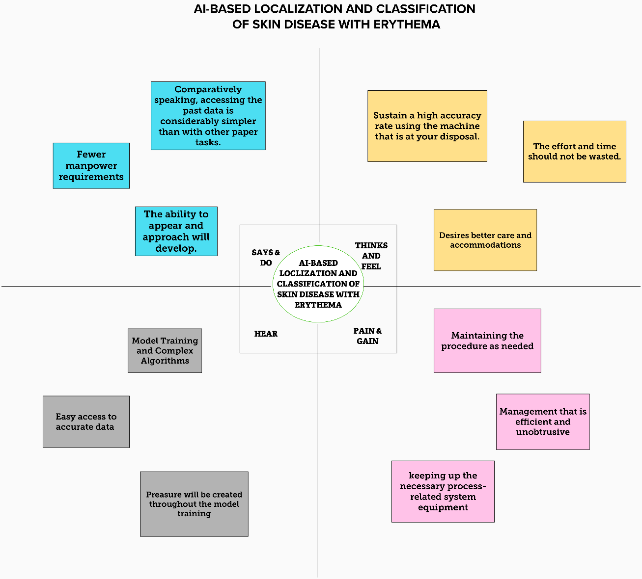

3.3 IDEATION PHASE brainstrom

Step 1:

Step 2:

Step 3:

PROPOSED SOLUTION

S .No | Parameter | Description
1. | Problem Statement | The characteristic of the skin images is diversified so it is a challenging job to devise an efficient and robust algorithm for the automatic detection of skin disease and its severity
2. | Solution description | We will be developing the AI used application  to detect the skin disease by capturing the infected area.
3. | Novelty / Uniqueness | Fast mode to identify the type of skin disease and highly accurate.
4. | Social Impact / Customer Satisfaction | It helps the person to get the quick result and fast consulting.
5. | Business Model | This application helps the people to identify the seriousness about the disease and to find what kind of skin disease it is.
6. | Scalability of the Solution | This use of application will reach all the peoples  who were affected with skin disease globally to get the quick report about their skin.

PROBLEM SOLUTION FIT

Functional requirements-pg no:17
Non Functional-pg no :18

4.3 SOLUTION and technical ARCHITECTURE

Solution Architecture:
Solution architecture is a complex process – with many sub-processes – that bridges the gap between problems and technology solutions. Its goals are to:
- Find the best tech solution to solve existing problems.
- Describe the structure, characteristics, behavior, and other aspects of the software to detect the Skin Disease.
- Define features, development phases, and solution requirements.
- Provide specifications according to which the solution is defined, managed, and delivered.
Example - Solution Architecture Diagram:

User stores

REQUIREMENTS
Functional requirements

Following are the functional/Solution requirements of the proposed solution.
FR  No. | Functional Requirement (Epic) | Sub Requirement (Story / Sub-Task)
FR-1 | User Registration | Registration through Gmail
FR-2 | User Confirmation | Confirmation via Email
FR-3 | User Login | Login with username  Login with password
FR-4 | User Camera | Capture the Skin Disease using a Camera
FR-5 | Image to Report | Detects the skin disease and gives the result
FR-6 | Conversion of the image to the detected Result | Reports of the Skin disease will be sent in the form of text
FR-7 | Ratings and Reviews | The user can give their ratings and view of this models

Non-functional Requirements:
Following are the non-functional requirements of the proposed solution.
FR  No. | Non-Functional Requirement | Description
NFR-1 | Usability | They can be used with a camera by capturing the Skin
NFR-2 | Security | This can be used only by the users who have their proper login credentials . Highly secured and protected using the AI models.
NFR-3 | Reliability | It can be used everywhere and every time without any issues.
NFR-4 | Performance | From this, the model can predict the Skin Disease. The accuracy of this model will be ensured by checking multiple times.
NFR-5 | Availability | This model is suitable for all kinds of retail stores. It can give retailers real-time visibility into stock levels,avoid stockouts, keep inventory carrying costs low and help meet customer expectations
NFR-6 | Scalability | More users can be accessed at the same time without any issues. The feedback of the users will be taken and be proceeded further up to the satisfaction of the user.

5.3 DATA FLOW DIAGRAM

Data Flow Diagram:
A Data Flow Diagram (DFD) is a traditional visual representation of the information flows within a system. A neat and clear DFD can depict the right amount of the system requirement graphically. It shows how data enters and leaves the system, what changes the information, and where data is stored.

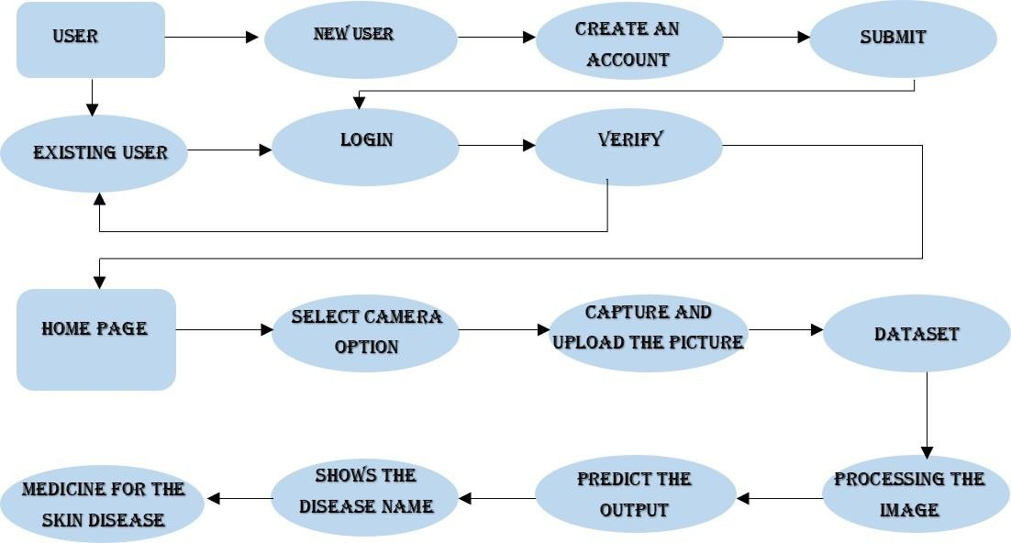

User Type | Functional  Requirement  (Epic) | User Story  Number | User Story / Task | Acceptance criteria | Priority | Release
Customer  (Mobile user) | Registration | USN-1 | As a user, I can register for the web application by entering my email, password, and confirming my password. | I can access my account / dashboard | High | Sprint-1
 |  | USN-2 | As a user, after completing the registration I will receive confirmation email once I have registered for the web application | I can receive confirmation email & click confirm | High | Sprint-1
 |  | USN-3 | As a user, I can register for the web application through LinkedIn | I can register & access the  dashboard with LinkedIn Login | Low | Sprint-2
 |  | USN-4 | As a user, I can register for the web application through Google account | I can register & access the dashboard with Gmail login | Medium | Sprint-1
 | Login | USN-5 | As a user, I can log into the application by entering email & password after installing the web application | I can access the dashboard by login into the application | High | Sprint-1
 | Dashboard | USN-6 | As a user, I can view the charts and graphs representation of the dataset and the information shown in the dashboard | I can analyse the stocks in my retail store. | High | Sprint-1
Customer (Web user) | Registration | USN-1 | As a user, I can register for the web application entering my email, password,confirming my password. | I can access my account / dashboard | High | Sprint-1
Customer Care Executive |  | USN-2 | As a user, after completing the registration I will receive confirmation email once I have registered for the web application | I can receive confirmation email & click confirm | High | Sprint-1

User Type | Functional  Requirement  (Epic) | User Story  Number | User Story / Task | Acceptance criteria | Priority | Release
Administrator |  | USN-3 | As a user, I can register for the web application through LinkedIn | I can register & access the dashboard with LinkedIn Login | Low | Sprint-2
 |  | USN-4 | As a user, I can register for the web application through Google account | I can register & access the dashboard with Gmail login | Medium | Sprint-1
 | Login | USN-5 | As a user, I can log into the web application  by entering email & password after installing the application. | I can access the dashboard by login into the application | High | Sprint-1
 | Dashboard | USN-6 | As a user, I can view the charts and graphs representation of the dataset and the information shown in the dashboard. | I can analyse the Skin Disease through the report | High | Sprint-1
Customer Care  Executive | Solution | CCE-1 | As a customer care executive, I will always be available for the interaction with the customer to clarify the queries. | An executive will analyse the customer complaints, rectify their problems | High | Sprint-2
Administrator | Manage | ADMIN-1 | Do-it-yourself service for delivering Everything. | Set of predefined requirements that must  be met to mark a user story complete. | High | Sprint-2

Technical Architecture:

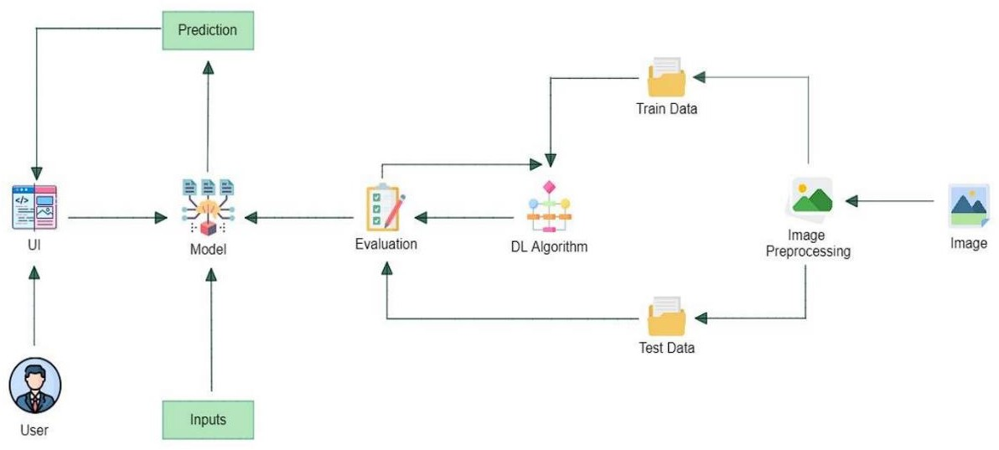

Table-1 : Components & Technologies:

S.No | Component | Description | Technology
1. | User Interface | User interacts with the application using a website. | Python Flask
2. | Image Pre-processing | Image of the diseased spot is uploaded through the website and the image is pre-processed using machine learning algorithms. | Python
3. | Disease Prediction | Machine learning model to predict the diseases from the images of the diseases uploaded through the webapp | Python
4. | Mitigation | After predicting the disease, identification and mitigation that particular disease is suggested.  Watson Assistant plays a great role in assisting in these processes. | Python, IBM Watson Assistant
5. | Database | Images are stored in the database. | MySQL, NoSQL, etc..
6. | Cloud Database | The above-described model is deployed in the IBM cloud. | IBM DB2, IBM Cloudant etc.
7. | File Storage | Files are been stored in cloud. | IBM Block Storage or Other Storage Service or Local Filesystem

Table-2: Application Characteristics:

S.No | Characteristics | Description | Technology
1. | Open-Source Frameworks | Google Collaboratory, Jupyter Notebook, Google drive, Python Flask. | Technology of Opensource framework
2. | Security Implementations | Some kind of encryption will be done, as this is a web app the owasp will be taken into consideration. | SHA-256, Encryptions, IAM Controls, OWASP etc.
3. | Scalable Architecture | The scalability architecture used is 2-tier architecture. The client is the user and the server is the IBM cloud server where the model will be  deployed. | Python Flask, IBM cloud
4. | Availability | The website will be deployed in the IBM cloud and will be available for all the users to use irrespective of the organisation or the institution they belong to | IBM cloud
5. | Performance | As the models and the web applications are deployed in the IBM cloud remote server the website can handle maximum number of requests and can be scaled at ease | IBM cloud

6. Project planning phase

6.1sprint planning and estimating

6.2 SPRINT DELIVERY PLAN

Product backlogs, Sprint schedule, Estimation(4 marks)

Project Tracker, Velocity & Burndown Chart: (4 Marks)

Velocity:

Imagine we have a 10-day sprint duration, and the velocity of the team is 20 (points per sprint). Let’s calculate the team’s average velocity (AV) per iteration unit (story points per day)

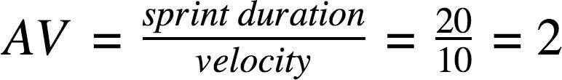

Burndown Chart:

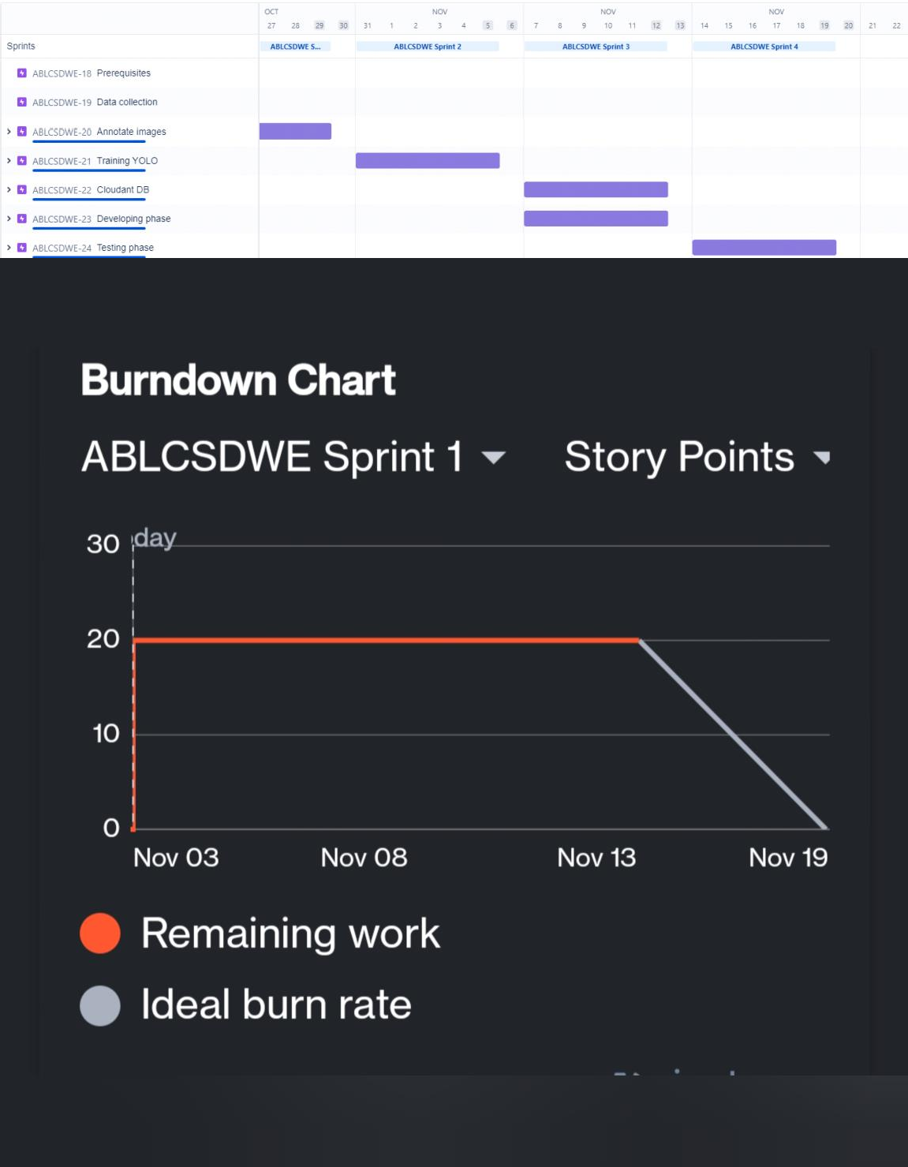

Coding and solutioning

Feature 1

Feature 2:

# Part 1 - Building the CNN
#importing the Keras libraries and packages
from keras.models import Sequential
from keras.layers import Convolution2D
from keras.layers import MaxPooling2D
from keras.layers import Flatten
from keras.layers import Dense, Dropout
from keras import optimizers

# Initialing the CNN
classifier = Sequential()

# Step 1 - Convolution Layer
classifier.add(Convolution2D(32, 3, 3, input_shape = (64, 64, 3), activation = 'relu'))

#step 2 - Pooling
classifier.add(MaxPooling2D(pool_size =(2,2)))

# Adding second convolution layer
classifier.add(Convolution2D(32, 3, 3, activation = 'relu'))
classifier.add(MaxPooling2D(pool_size =(2,2)))

#Adding 3rd Concolution Layer
classifier.add(Convolution2D(64, 3, 3, activation = 'relu'))
classifier.add(MaxPooling2D(pool_size =(2,2)))

#Step 3 - Flattening
classifier.add(Flatten())

#Step 4 - Full Connection
classifier.add(Dense(256, activation = 'relu'))
classifier.add(Dropout(0.5))
classifier.add(Dense(10, activation = 'softmax'))

#Compiling The CNN
classifier.compile(
optimizer = 'adam',
loss = 'categorical_crossentropy',
metrics = ['accuracy'])

#Part 2 Fittting the CNN to the image
from keras.preprocessing.image import ImageDataGenerator
train_datagen = ImageDataGenerator(
rescale=1./255,
shear_range=0.2,
zoom_range=0.2,
horizontal_flip=True)

test_datagen = ImageDataGenerator(rescale=1./255)

training_set = train_datagen.flow_from_directory(
'Data/train',
target_size=(64, 64),
batch_size=32,
class_mode='categorical')

test_set = test_datagen.flow_from_directory(
'Data/test',
target_size=(64, 64),
batch_size=32,
class_mode='categorical')

model = classifier.fit_generator(
training_set,
steps_per_epoch=100,
epochs=100,
validation_data = test_set,
validation_steps = 6500
)

#Saving the model
import h5py
classifier.save('Trained_Model.h5')

print(model.history.keys())
import matplotlib.pyplot as plt

# summarize history for accuracy
plt.plot(model.history['acc'])
plt.plot(model.history['val_acc'])
plt.title('model accuracy')
plt.ylabel('accuracy')
plt.xlabel('epoch')
plt.legend(['train', 'test'], loc='upper left')
plt.show()

# summarize history for loss
plt.plot(model.history['loss'])
plt.plot(model.history['val_loss'])
plt.title('model loss')
plt.ylabel('loss')
plt.xlabel('epoch')
plt.legend(['train', 'test'], loc='upper left')
plt.show()

PKL:

# Part 1 - Building the CNN
#importing the Keras libraries and packages
from keras.models import Sequential
from keras.layers import Convolution2D
from keras.layers import MaxPooling2D
from keras.layers import Flatten
from keras.layers import Dense, Dropout
from keras import optimizers

# Initialing the CNN
classifier = Sequential()

# Step 1 - Convolution Layer
classifier.add(Convolution2D(32, 3, 3, input_shape = (64, 64, 3), activation = 'relu'))

#step 2 - Pooling
classifier.add(MaxPooling2D(pool_size =(2,2)))

# Adding second convolution layer
classifier.add(Convolution2D(32, 3, 3, activation = 'relu'))
classifier.add(MaxPooling2D(pool_size =(2,2)))

#Adding 3rd Concolution Layer
classifier.add(Convolution2D(64, 3, 3, activation = 'relu'))
classifier.add(MaxPooling2D(pool_size =(2,2)))

#Step 3 - Flattening
classifier.add(Flatten())

#Step 4 - Full Connection
classifier.add(Dense(256, activation = 'relu'))
classifier.add(Dropout(0.5))
classifier.add(Dense(10, activation = 'softmax'))

#Compiling The CNN
classifier.compile(
optimizer = 'adam',
loss = 'categorical_crossentropy',
metrics = ['accuracy'])

#Part 2 Fittting the CNN to the image
from keras.preprocessing.image import ImageDataGenerator
train_datagen = ImageDataGenerator(
rescale=1./255,
shear_range=0.2,
zoom_range=0.2,
horizontal_flip=True)

test_datagen = ImageDataGenerator(rescale=1./255)

training_set = train_datagen.flow_from_directory(
'Data/train',
target_size=(64, 64),
batch_size=32,
class_mode='categorical')

test_set = test_datagen.flow_from_directory(
'Data/test',
target_size=(64, 64),
batch_size=32,
class_mode='categorical')

model = classifier.fit_generator(
training_set,
steps_per_epoch=100,
epochs=100,
validation_data = test_set,
validation_steps = 6500
)

#Saving the model
import h5py
classifier.save('Trained_Model.h5')

print(model.history.keys())
import matplotlib.pyplot as plt

# summarize history for accuracy
plt.plot(model.history['acc'])
plt.plot(model.history['val_acc'])
plt.title('model accuracy')
plt.ylabel('accuracy')
plt.xlabel('epoch')
plt.legend(['train', 'test'], loc='upper left')
plt.show()

# summarize history for loss
plt.plot(model.history['loss'])
plt.plot(model.history['val_loss'])
plt.title('model loss')
plt.ylabel('loss')
plt.xlabel('epoch')
plt.legend(['train', 'test'], loc='upper left')
plt.show()

Sample:

# Part 1 - Building the CNN
#importing the Keras libraries and packages
from keras.models import Sequential
from keras.layers import Convolution2D
from keras.layers import MaxPooling2D
from keras.layers import Flatten
from keras.layers import Dense, Dropout
from keras import optimizers

# Initialing the CNN
classifier = Sequential()

# Step 1 - Convolution Layer
classifier.add(Convolution2D(32, 3, 3, input_shape = (64, 64, 3), activation = 'relu'))

#step 2 - Pooling
classifier.add(MaxPooling2D(pool_size =(2,2)))

# Adding second convolution layer
classifier.add(Convolution2D(32, 3, 3, activation = 'relu'))
classifier.add(MaxPooling2D(pool_size =(2,2)))

#Adding 3rd Concolution Layer
classifier.add(Convolution2D(64, 3, 3, activation = 'relu'))
classifier.add(MaxPooling2D(pool_size =(2,2)))

#Step 3 - Flattening
classifier.add(Flatten())

#Step 4 - Full Connection
classifier.add(Dense(256, activation = 'relu'))
classifier.add(Dropout(0.5))
classifier.add(Dense(10, activation = 'softmax'))

#Compiling The CNN
classifier.compile(
optimizer = 'adam',
loss = 'categorical_crossentropy',
metrics = ['accuracy'])

#Part 2 Fittting the CNN to the image
from keras.preprocessing.image import ImageDataGenerator
train_datagen = ImageDataGenerator(
rescale=1./255,
shear_range=0.2,
zoom_range=0.2,
horizontal_flip=True)

test_datagen = ImageDataGenerator(rescale=1./255)

training_set = train_datagen.flow_from_directory(
'Data/train',
target_size=(64, 64),
batch_size=32,
class_mode='categorical')

test_set = test_datagen.flow_from_directory(
'Data/test',
target_size=(64, 64),
batch_size=32,
class_mode='categorical')

model = classifier.fit_generator(
training_set,
steps_per_epoch=100,
epochs=100,
validation_data = test_set,
validation_steps = 6500
)

#Saving the model
import h5py
classifier.save('Trained_Model.h5')

print(model.history.keys())
import matplotlib.pyplot as plt

# summarize history for accuracy
plt.plot(model.history['acc'])
plt.plot(model.history['val_acc'])
plt.title('model accuracy')
plt.ylabel('accuracy')
plt.xlabel('epoch')
plt.legend(['train', 'test'], loc='upper left')
plt.show()

# summarize history for loss
plt.plot(model.history['loss'])
plt.plot(model.history['val_loss'])
plt.title('model loss')
plt.ylabel('loss')
plt.xlabel('epoch')
plt.legend(['train', 'test'], loc='upper left')
plt.show()

Skin Disease Model:

# Part 1 - Building the CNN
#importing the Keras libraries and packages
from keras.models import Sequential
from keras.layers import Convolution2D
from keras.layers import MaxPooling2D
from keras.layers import Flatten
from keras.layers import Dense, Dropout
from keras import optimizers

# Initialing the CNN
classifier = Sequential()

# Step 1 - Convolution Layer
classifier.add(Convolution2D(32, 3, 3, input_shape = (64, 64, 3), activation = 'relu'))

#step 2 - Pooling
classifier.add(MaxPooling2D(pool_size =(2,2)))

# Adding second convolution layer
classifier.add(Convolution2D(32, 3, 3, activation = 'relu'))
classifier.add(MaxPooling2D(pool_size =(2,2)))

#Adding 3rd Concolution Layer
classifier.add(Convolution2D(64, 3, 3, activation = 'relu'))
classifier.add(MaxPooling2D(pool_size =(2,2)))

#Step 3 - Flattening
classifier.add(Flatten())

#Step 4 - Full Connection
classifier.add(Dense(256, activation = 'relu'))
classifier.add(Dropout(0.5))
classifier.add(Dense(10, activation = 'softmax'))

#Compiling The CNN
classifier.compile(
optimizer = 'adam',
loss = 'categorical_crossentropy',
metrics = ['accuracy'])

#Part 2 Fittting the CNN to the image
from keras.preprocessing.image import ImageDataGenerator
train_datagen = ImageDataGenerator(
rescale=1./255,
shear_range=0.2,
zoom_range=0.2,
horizontal_flip=True)

test_datagen = ImageDataGenerator(rescale=1./255)

training_set = train_datagen.flow_from_directory(
'Data/train',
target_size=(64, 64),
batch_size=32,
class_mode='categorical')

test_set = test_datagen.flow_from_directory(
'Data/test',
target_size=(64, 64),
batch_size=32,
class_mode='categorical')

model = classifier.fit_generator(
training_set,
steps_per_epoch=100,
epochs=100,
validation_data = test_set,
validation_steps = 6500
)

#Saving the model
import h5py
classifier.save('Trained_Model.h5')

print(model.history.keys())
import matplotlib.pyplot as plt

# summarize history for accuracy
plt.plot(model.history['acc'])
plt.plot(model.history['val_acc'])
plt.title('model accuracy')
plt.ylabel('accuracy')
plt.xlabel('epoch')
plt.legend(['train', 'test'], loc='upper left')
plt.show()

# summarize history for loss
plt.plot(model.history['loss'])
plt.plot(model.history['val_loss'])
plt.title('model loss')
plt.ylabel('loss')
plt.xlabel('epoch')
plt.legend(['train', 'test'], loc='upper left')
plt.show()

CONCLUSION

Now a day’s people are suffering from skin diseases, More than 125 million people suffer from Psoriasis also the skin cancer rate is rapidly increasing over the last few decades especially Melanoma is the most diverse skin cancer. If skin diseases are not treated at an earlier stage, then it may lead to complications in the body including the spreading of the infection from one individual to the other. Skin diseases can be prevented by investigating the infected region at an early stage. The characteristic of the skin images is diversified so it is a challenging job to devise an efficient and robust algorithm for the automatic detection of skin disease and its severity. Skin tone and skin color play an important role in skin disease detection. The color and coarseness of skin are visually different. Automatic processing of such images for skin analysis requires a quantitative discriminator to differentiate the diseases.

We have shown that even without a large dataset and high-quality images, it is possible to achieve sufficient accuracy rates. In addition, we have shown that current state-of-the-art CNN models can outperform models created by previous research, through proper data preprocessing, self-supervised learning, transfer learning, and special CNN architecture techniques. Furthermore, with accurate segmentation, we gain knowledge of the location of the disease, which is useful in the preprocessing of data used in classification, as it allows the CNN model to focus on the area of interest. Lastly, unlike previous studies, our method provides a solution to classify multiple diseases within a single image. With higher quality and a larger quantity of data, it will be viable to use state-of-the-art models to enable the use of CAD in the field of dermatology.

REFERENCES

- Rajab, M. I., Woolfson, M. S. & Morgan, S. P. Application of region-based segmentation and neural network edge detection to skin lesions. Comput. Med. Imaging Graph. 28, 61–68. https://doi.org/10.1016/S0895-6111(03)00054-5 (2004).

- Keke, S., Peng, Z. & Guohui, L., Study on skin color image segmentation used by fuzzy-c-means arithmetic. In 2010 Seventh International Conference on Fuzzy Systems and Knowledge Discovery, Yantai, 612–615. https://doi.org/10.1109/FSKD.2010.55694 51 (2010).

- Albawi, S., Mohammed, T. A. & Al-Zawi, S., Understanding of a convolutional neural network. In 2017 International Conference on Engineering and Technology (ICET), Antalya, 1–6. https://doi.org/10.1109/ICEngTechnol.2017.8308186 (2017).

- Ronneberger, O., Fischer, P. & Brox, T. U-net: Convolutional networks for biomedical image segmentation. Medical image computing and computer-assisted intervention—MICCAI 2015. MICCAI 2015. In Lecture Notes in Computer Science Vol. 9351 (eds Navab, N. et al.) 234–241 (Springer, Berlin, 2015).

- Tschandl, P., Rosendahl, C. & Kittler, H. Te HAM10000 dataset, a large collection of multi-source dermatoscopic images of common pigmented skin lesions. Sci. Data 5, 180161. https://doi.org/10.1038/sdata.2018.161 (2018).

- Selvaraju, R. et al. Grad-CAM: Visual explanations from deep networks via gradient-based localization. Int. J. Comput. Vis. 128, 336–359. https://doi.org/10.1007/s11263-019-01228-7 (2019).

- Tan, M. & Le, Q., Efcientnet: Rethinking model scaling for convolutional neural networks, in ICML, 6105–6114. https://arxiv .org/abs/1905.11946 (2019).

- Chawla, N., Bowyer, K., Hall, L. & Kegelmeyer, W. SMOTE: Synthetic minority over-sampling technique. J. Artif. Intell. Res. 16, 321–357. https://doi.org/10.1613/jair.953 (2002).

- Lu, J., Manton, J. H., Kazmierczak E. & Sinclair, R., Erythema detection in digital skin images. In 2010 IEEE International Conference on Image Processing, Hong Kong, 2545–2548. https://doi.org/10.1109/ICIP.2010.5653524 (2010).

- Sumithra, R., Suhil, M. & Guru, D. S. Segmentation and classifcation of skin lesions for disease diagnosis. Proced. Comput. Sci. 45, 76–85. https://doi.org/10.1016/j.procs.2015.03.090 (2015).

- Maglogiannis, I., Zafropoulos, E. & Kyranoudis, C. Intelligent segmentation and classifcation of pigmented skin lesions in dermatological images in Advances in Artifcial Intelligence. SETN 2006. In Lecture Notes in Computer Science Vol. 3955 (eds Antoniou, G. et al.) 214–223 (Springer, Berlin, 2006).

- Doi, K. Computer-aided diagnosis in medical imaging: Historical review, current status and future potential. Comput. Med. Imaging Graph. 31, 198–211. https://doi.org/10.1016/j.compmedimag.2007.02.002 (2007).

- Yoshida, H. & Dachman, A. H. Computer-aided diagnosis for CT colonography. Semin. Ultrasound CT MRI 25, 419–431. https:// doi.org/10.1053/j.sult.2004.07.002 (2004).

- Trabelsi, O., Tlig, L., Sayadi, M. & Fnaiech, F., Skin disease analysis and tracking based on image segmentation. 2013 International Conference on Electrical Engineering and Sofware Applications, Hammamet, 1–7. https://doi.org/10.1109/ICEESA.2013.6578486 (2013).

Demonstration Link:

https://drive.google.com/file/d/1k61jdxGrfh_y06ikcYH0KSB5j2poHoMj/view?usp=sharing

Github Repo: https://github.com/IBM-EPBL/IBM-Project-34783-1660276607

